**LONDON METROPOLITAN UNIVERSITY**

09

**PROTOTYPE DEVELOPMENT OF ACTIVE CONDITIONAL MONITORING SYSTEM**

**ADEYEMI ADEKUNLE**

**06052450**

**M.Sc COMPUTING**

**RESEARCH AND DEVELOPMENT SKILL (CCP155N)**

**TABLE *OF CONTENT***

TABLE OF CONTENT 2

SUMMARY 3

REVIEW OF CURRENT STATE OF PROPOSED AREA 4

CURRENT STATE OF PRINCIPLE OF ACTIVE SAFETY SYSTEM (PASS) 7

PROJECT PLAN 10

RISK ANALYSIS 13

* TIME SHOTAGE 13

RESOURCES NEEDED 14

* SOFTWARE 14
* HARDWARE 14
* PEOPLE 14
* TRAINING NEED 14
* SECURITY OF PROJECT AND CONFIDENTIALITY 14

ETHICAL, LEGAL, AND PROFESSIONAL ISSUES 16

* DATA PROTECTION 16
* INTELLECTUAL PROPERTY 16
* COMPUTER MISUSE 16
* CODE OF ETHICS 16
* HUMAN ADULTS 16
* HUMAN CHILDREN 16

REFERENCE 17

***SUMMARY***

The safety of air transportation has been a major concern for the world in general because of its mortality. The mortality rates has reduced over the years due to the development of safety software and increase in technology, but for the last one decade it remained the same and for achievement of lowest mortality rate in the aviation sector, safety regulation has been going through various reviews and sophisticated safety software has been developed.

This fact has given rise to development of new technologies in this sector and this includes the active safety system. This system PASS (Principle of Active Safety System) was proposed in 1994 aimed at offering comprehensive preventive analysis and management of slight safety in real time so as to achieve the mortality rate stated above. The research was granted in 1999 by the European union. Active Conditional Monitoring System is a part of this system that will monitor the states of elements of an object (aircraft) before and during take-off, during flights, and landing in correlation with recorded data.

This system will not only monitor the aircraft but also alert the right authority e.g the pilot, control tower, regulatory bodies, e.t.c, of any potential damage that may cause accidents and/or incidents in terms of the elements or the equipments of the aircraft. The system will also records the condition of the aircraft at any particular point in time putting into consideration data recorded from previous flights and the different states of the elements or components and determining normal and abnormal states for further analysis.

When this system is fully developed and incorporated into PASS system, the aviation safety will be taken to another dimension and not only in aviation sector but also the transportation industry in general.

***Review of Current State of Proposed Area***

The aviation sector is divided into different sectors considering different factors which include the flights mission, the mode or method of operation, the technical specification and the state of development of the aircraft [2]. But generally it can be divided into two; military and civil aviation. The military aviation safety will not be looked in detail because of high sensitivity in the information, but the safety procedure had been adapted to the function of the hardware and software of the planes basically because it contains mostly two pilots and has been modified for combats and other special functions.

The civil aviation sector is further divided into two, namely general aviation (GA) and commercial aviation (CA) [2]. In this sector, the safety regulation and analysis has been improving over the years most especially in the Commercial Aviation but the “*accidents*” (which is an event when any person suffers death or serious injury and aircraft receives substantial damage), and/or “*incidents*” (which is an occurrence different from an accidents associated with the operation of an aircraft which could affect safety of operations) [1] in the General Aviation sector was still in the rise.

It was observed that the Aviation industry is been affected by some critical factors which include

1. The increase in air traffic
2. The increase in complex aircrafts
3. Increasing passengers
4. High maintenance overheads
5. Increase in luggage capacity.

Along with these factors came the increase in theoretical and technological advancements and these have led to increase in risks.

***RISK AND RISK FACTORS***

Statistics showed that there had been improvements in the aviation safety in the CA sector. This shows that the number of accidents has been reduced to 1 per 5 per million departures (fig 1) [4]

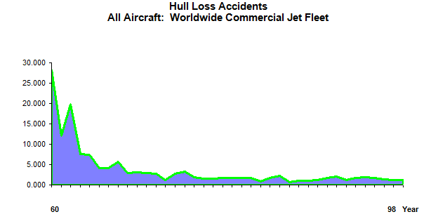

**Fig.1. Accident statistics per million departures (Source [5])**

But still with the statistics above, other sectors still has great danger and high risk of accidents and incidents, most especially in GA sector. This is because apart from the general risks that affect aviation sector, the GA is affected by specific features due to nature and environmental operations.

Some factors influences risks, some of which include loss of control in flights, control flights in terrain, mechanical malfunctioning, mid-air collision, environmental and climatic conditions [4]. Other factors that influence risk factors are human, equipment factors.

These factors were found to affects the flights in aviation at different phases and these phases can be divided into five as follows

* The taxi-out phase
* The climbing phase (take-off)
* The in- flight phase
* Descent phase (landing)
* Taxi in phase

Aviation statistics on accidents found out that take-off and the landing phases are the most risky phases and record the highest cases of accidents.

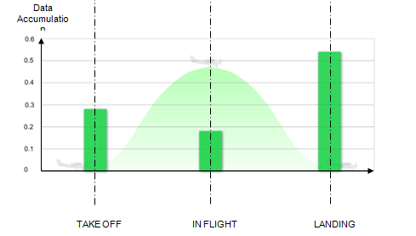

***Fig***.***2 Statistics of accidents in phases [7]***

And from this figure above the accident in GA is ten times these statistics but with the same graphical curve. For the reduction of these accidents, the risk profile for all phases most especially the dangerous phases must be monitored and managed and be brought to about nearest minimum.

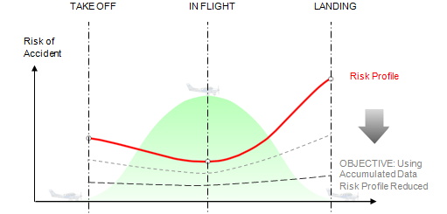

***Fig 3. Propose Level of Risk Reduction[7]***

This led to the development various safety technology which include the PASS.

***CURRENT STATE OF PRICINPLE OF ACTIVE SAFETY SYSTEM (PASS)***

The PASS came into existence when a project called ONBASS (On Board Active Safety Systems) was developed in 1994[3]. This system proposed a way of monitoring the general functionalities of an aircraft to know at any particular point in time what the cause of incidents or accident is/are and suggest ways of averting or reducing the cause in real time.

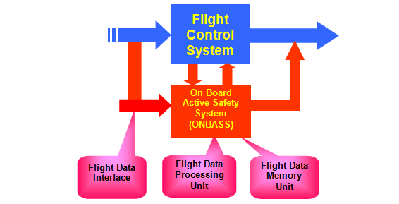

***Fig 4 Overview of the ONBASS System [3]***

The project emphasises that events that reduces safety in aircrafts can be avoided by predicting its occurrence using the flight data through monitoring the conditions of the elements of the objects (the aircraft) with some other derivatives which are the functional model of the elements, real time flight data, operational flight mode, predicates of an object and the states of its elements, a dependent matrix (which is a relation between a faulty behaviour of an elements and the occurrence of an event) and a recovery matrix (which describes what can be done when a particular situation occurs). This can be modelled with the diagram below

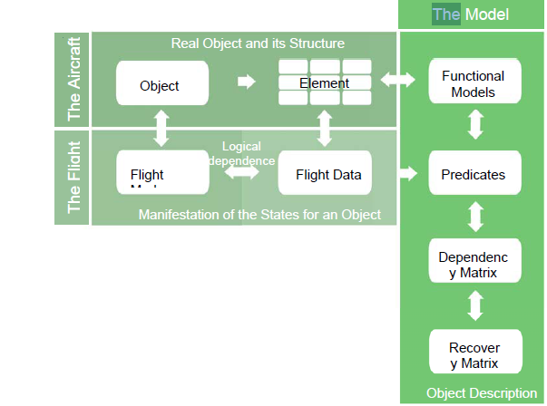

Fig.5. ***THE MASSA STRUCTURE [ source 4]***

But the active conditional monitoring system focuses on the interdependence of the functional model, flight data and the elements only.

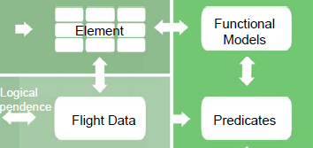

Fig.6 ***THE INTERDEPENDENCY OF ELEMENT, DATA***

***AND FUNTIONAL MODEL[source 4]***

This system will depend on the the dependency and the recovery matrixes in that data recorded in the flight data have some variables which are sent from the sensors of the object throught their elements and these are compared with the functional models.

The functional model will be developed as well as the explicit representation of their dependency [4] so as to make the analysis of the flight data be analyse in real time.

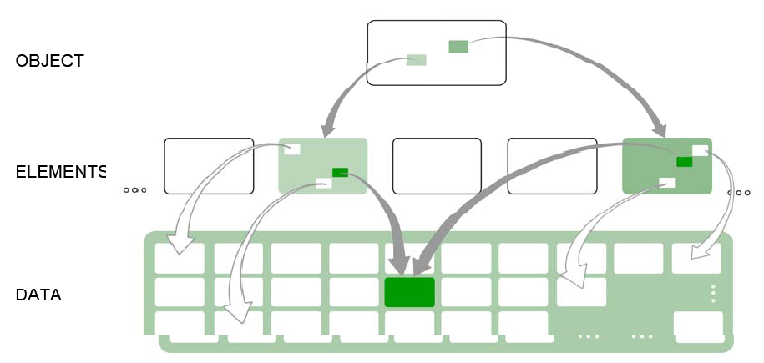

Fig.7. ***Dependency of data and elements [source 4]***

***PROJECT PLAN***

This project was due to start in June 2009 and expected to be completed and report submitted by December 2009. To achieve this stipulated date, a project plan has been mapped out to see easy running of the project. The key area of the whole project has been noted and each step to been taken for the completion of the project are as follows

1. Background research on the safety management of the aviation sector
2. Understanding of the ONBASS Project with key features
3. Risk analysis, ethical issues and project proposal report
4. Understanding existing software and identifying the platform and programming to be used
5. Identifying hardware to be incorporated
6. Designing the software
7. Testing and debugging
8. Implementation and justification
9. Documentation.

The following steps can be represented by the table shown below with the start dates and the end dates of the project with the assumption that it’s been carried out throughout the week.

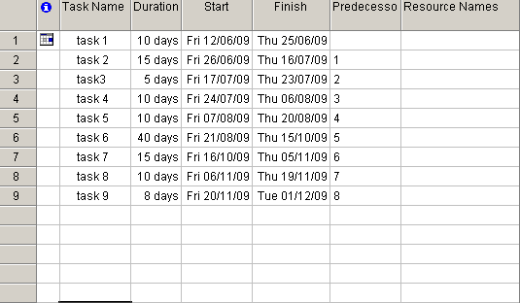

Fig.7 ***Start dates and End dates for the projects***

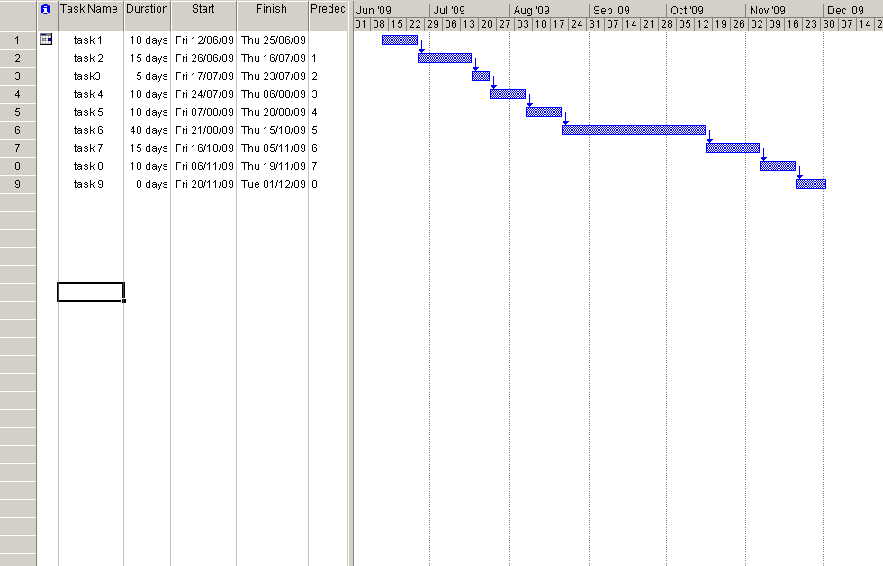

Fig.8 ***Start date and End date with Probable Gantt Chart***

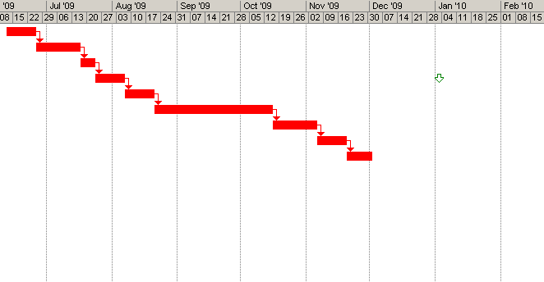

Fig.9 ***Detailed Gantt chart***

Fig.10 ***Gantt chart from Excel***

***RISK ANALYSIS***

Like any project, this project contain some constrains which can be due to either, the requirement, the quality expected or the budget in terms of cost. These factors can be related by the diagram below

Requirement

Time scale

Budget/Resources

Fig.11 ***Project Management frame work***

Different things can actually go wrong in the project which can include inadequate resources, shortage of man power, or the time scale for the product deliverable is short.

***TIME SHORTAGE***

Time shortage is a kind of risk which can affect the whole project including the submission date if not taking into serious consideration. This can be due to not allocating enough time for either task 6, 7 or 8.

To reduce the probability of this risk from occurring, a contingency time frame has been put in place. This is by additional 10 days between the end of the project and the deadline date for submission of the project.

***RESOURCES NEEDED***

**Software**

Basically the programming language to be use to develop this system is called OBERON which is a language develop in 1986. This language runs on Oberon operating system which the university does not have but it can run as a virtual machine with any hosting operating system.

**Hardware**

This project requires a modern desktop computer which the university has. The desk top will have any operating system either windows or apple mac where the virtual machine stated above can run. A USB stick will also be needed to serve as an external backup.

**People**

The people involved in this project include

Research student – ADEYEMI ADEKUNLE

Research Supervisor – Prof IGOR SCHAGAEV

***TRAINING NEED***

Training will be given on the usage of the Oberon platform by the supervisor. But the student has good understanding of the Oberon language itself.

***SECURITY OF PROJECT AND CONFIDENTIALITY***

All outcome of this project remain the sole property of the student, the supervisor and London metropolitan university. All data, findings and product will be guarded safely and securely. The computer to be use will be in the research laboratory of the university and it will be under lock and key in the premises. Only authorize personnel will have access to the data and the result. Any result worth publishing will be taken to the right authority for publication into journal or magazine.

***ETHICAL, LEGAL, AND PROFESSIONAL ISSUES***

***DATA PROTECTION***

The data protection act of 1998 provides protection on information about a person which includes names, address, telephone, e-mails which can be used to identify the person. This project conforms to the act and the person(s) involve in this project, their data will not be disclose to anybody.

***INTELLECTUAL PROPERTY***

The software, and other materials such as books journals, online resources, e.t.c will be duly reference in any report made from this project and also certified copyright to the institution and other materials will be observed for proper conduct.

***COMPUTER MISUSE***

The UK computer Misuse act of 1990[15] warns against any unauthorized use of computer materials. No information on the university server will be use without proper authorization from the university. And also all rules and regulation of the ICT code of conduct [16] will be adhere to.

***CODE OF ETHICS***

This project does not violate the IEEE code of conduct for engineers. The project does not pose any threat to the community and the environment in general. But if there is any violation of the code of ethics the supervisor and the university will be notified and probably change or alter the project to conform with the code

***HUMAN ADULTS***

Nobody outside the project team is involved in this project but any contribution from anybody or organisation will be welcome as long as the laws are not violated.

***HUMAN CHILDREN***

No human children are involved in this project.

***REFERENCE***

1. Federal Aviation Administration, 1998, Washington, DC
2. ONBASS project, Deliverable 1.2 ONBASS Consortium, 2005,
3. PASS
4. Weener E., “Aviation Safety for the 21st century”, Invited Lecture 1998 ISSSC, Seattle.
5. United states GAO (General Accounting Office), GAO-01-96, “General Aviation Status of the Industry, Related Infrastructure, and safety Issues”, Report to Congressional Requester, August 2001.
6. Earl F. Weener 98 Commercial aviation Safety Challenges for the 21st Century, Presentation to Systems safety Conference September 16, 1998
7. Annex 1 – “Description of work”, Version 3.1, dd 12/11/2004, for ONBASS. Contract of the 6th European Framework Program: “Integrating and Strengthening the European Research Area, Thematic Priority” : Aeronautics and Space, Contract No: AST4-CT-2004-516045
8. Igor Schagaev., “Concept Of Dynamic Safety for Aviation” , 16th ISSC 1998, Seattle
9. Schagaev I ., Applying The Principle Of Active Safety To Aviation, 2nd EUCASS on Avionics, Control Systems and Information Technologies 2005
10. Schagaev I., Concept of Active System Safety. In Proc. 15th IFAC Symp. On Automatic Control in Aerospace Bologna/ Forli, Italy September 2001
11. Bukov V.N., Systems Embedding. Analysis and Design of Matrix Systems: An analytical approach. Kaluga: N Bochkareva Publishing house, 2006
12. Kirk B.R., Schagaev I.V., Method and Apparatus of Active System Safety. UK Patent Filing P54341GB, 2007
13. Birolini A., Reliability Engineering, 4th Edition, Springer Verlag, 2004
14. Aviziensis A., Laprie J-C., Randell B., Fundamental Concepts of Computer Systems Dependability. In IARP/ IEEE-RAS Workshop on Robot Dependability Seoul, Korea, May 21-22, 2001
15. The UK computer Misuse act 1990,<http://www.doc.gold.ac.uk/~mas01rk/Teaching/CIS110/notes/Computer-misuse.html> [accessed on 14 may 2009].
16. London Metropolitan University, ”Regulation For The Use of ICT, Library, and Media Resources, Services and Facilities”(2007), <http://www.londonmet.ac.uk/student-handbook0607/regulations-and-policies/ict-libraryand-media-resources.cfm> [accessed on 14th may 2009].